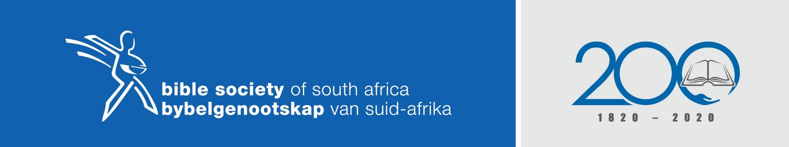
Bible Sunday 2021

By: Hein Barnard

Theme: Heal, Restore and Life

Scripture: Ephesians 6:10-20 (NIV)

Armour of God metaphors of grace. Wear the armour daily as we are in a constant spiritual battle.

- Defensive armour to restore
Belt Metaphor for truth which creates integrity and motivates to action
Defence against lies, fake news, half truths

Breastplate Metaphor for righteousness which is the outward expression of integrity
Living right, rooted in right thinking and right feeling / emotions
Defence against doubts whether we are right with God

Feet Metaphor to take the Gospel where it needs to be
Gospel of peace = reconciliation to all of humanity
Defence against giving up where there is opposition or rejection

Shield Metaphor for faith to protect us from Satan’s enmity to give up
Metaphor for faith to protect us from Satan’s opposition to thwart the will and purpose of God
Defence against giving up when we suffer, experience hardship

Helmet Metaphor for salvation. Mind is the “what” of faith and motivates our emotional response
The “what” of our faith is the Creeds
Defence against “mind games” people play when we suffer, meet opposition, prayers not answered

- Offensive armour to heal
Sword Metaphor for Spirit’s inspiration of sharing the Gospel of peace
Reveal the essence of God’s purposes for humanity through stories and history
Two-edged sword = 2 cut to the heart of the matter that brings healing
Defence to neutralise the enemy

- Prayer is Life
Believe in the defensive and offensive armour
Pray for yourself, the Lord’s people, preachers and bold preaching
Ask to wear it daily and be aware of God’s grace
Use armour to heal, restore and make life worthwhile

