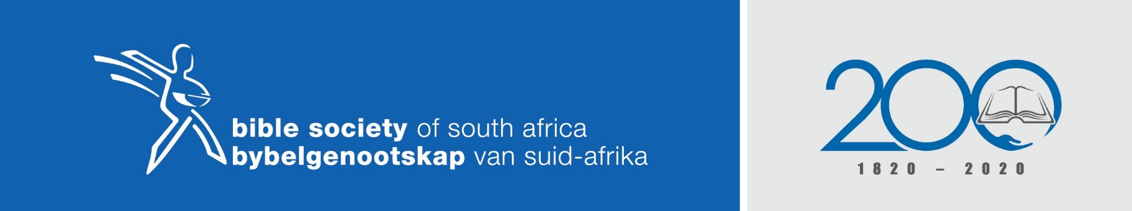
KHOLOFELO E SA LAHLETJEGO
Mathomo
Ditumedisho
Matseno a taba le go ikgokaganya le phuthego goba batheeletji.

MMELE
DINTLHA-KGOLO
Matseno le Mathomo a tabakgolo. Hlaloso le go tsopola mooko wa taba.
Temana-kgolo
Romans 5:5
- Re lokafaditswe ka tumelo go Jesu Kriste
- Rena le khutjo le Modimo ka Jesus Kriste
- Rena le tokelo ya matseno mogaung wa Modimo moo re emeng gona
- Re thaba kholofelong letagong la Modimo.
- Re ikgantsha matshwenyegong a rena.
- Mme kholofelo ga e re jeshe dihlong goba go re gobosha.

MARUMO/MAFELO
- Ka dinako tse bjalo, re swanela go bea tshepo goba kholofelo ya rena go Jesu eo elego Tshepo ya rena (Bakolose 1:27, Col1:27).
- Ge re eme re elwa mathateng, melekong le diphefong tja bophelo, ke ka lebaka la kholofelo eo e sa re jeshego dihlong.
- Ge batho ba botjisha go re ka lebaka la eng re sae me, re ka fetola ka mantsu a moopedi was Difela tsa Sione (323 & 108). Re eme fa, ka lebaka la kholofelo eo re nago le yona go Jesu Kriste! AMEN
- Ke go Jesu moo re emego gona, tse dingwe kamoka ke mohlaba o shishinyago!

